**GOVERNMENT COLLEGE OF ENGINEERING [IRTT]**

**ERODE: 638 316**



**Electronics and Communication Engineering**

**NAAN MUDHALVAN**

**DIGITAL MARKETING**

**ASSIGNMENT**

NM ID: FD0C19D7D2940E193DA4 D66EFA0EEBAC

NAME: VARSHA DEVI N

*BRAND NAME: POP_MUSIC_DOPE*

*CATEGORY: MUSIC*

1. Create a blog or website using Blogspot and WordPress. Customize the theme design and post new article with 500 words.

Link: Blog using Blogspot

<https://popmusicdope.blogspot.com/?m=1>

Screenshot:

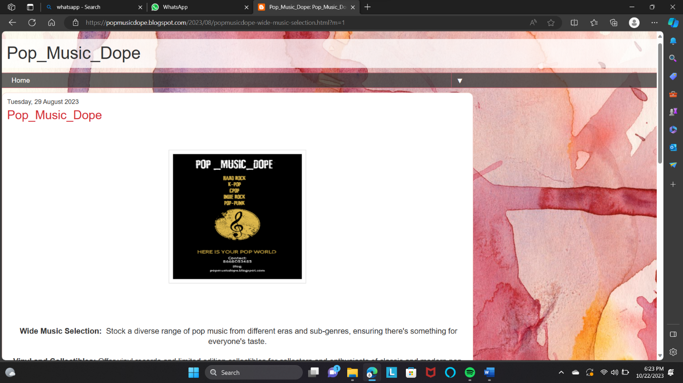

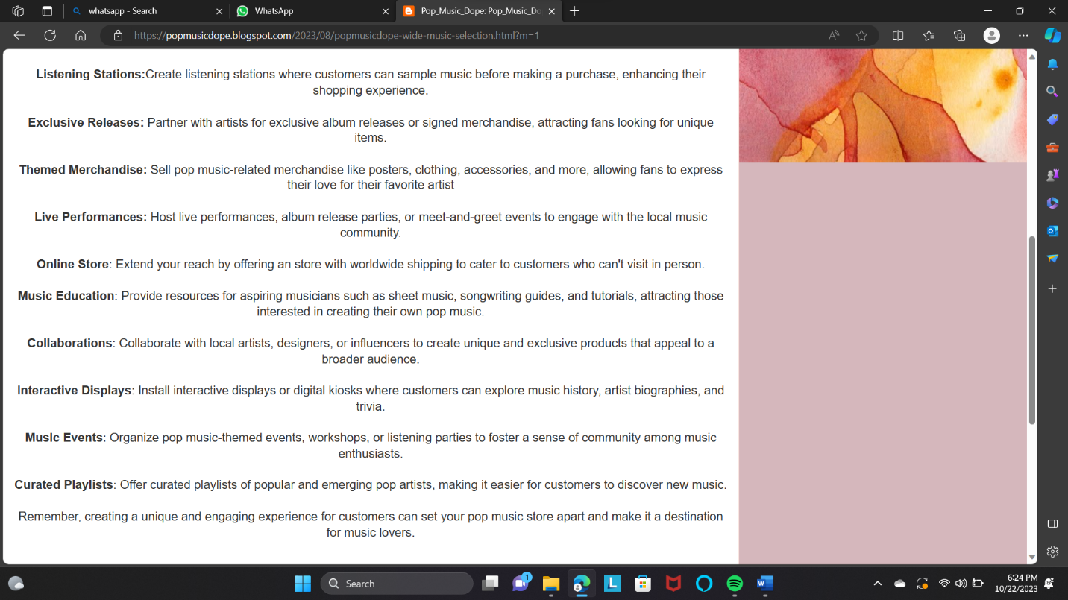

2.Create a New Facebook Business Page and post one social media poster for your brand.

Link: Facebook business page

<https://www.facebook.com/profile.php?id=61550231951827&mibextid=ZbWKwL>

Screen shot:

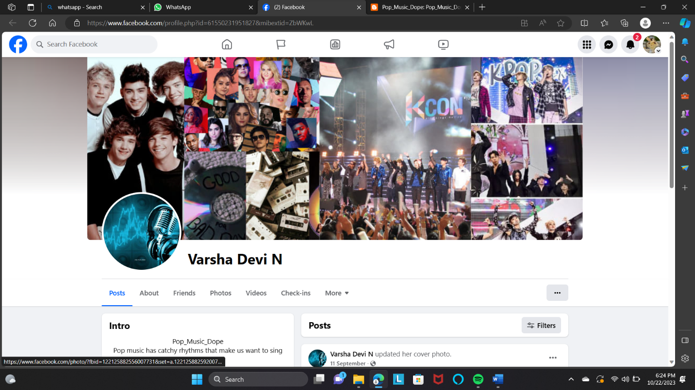

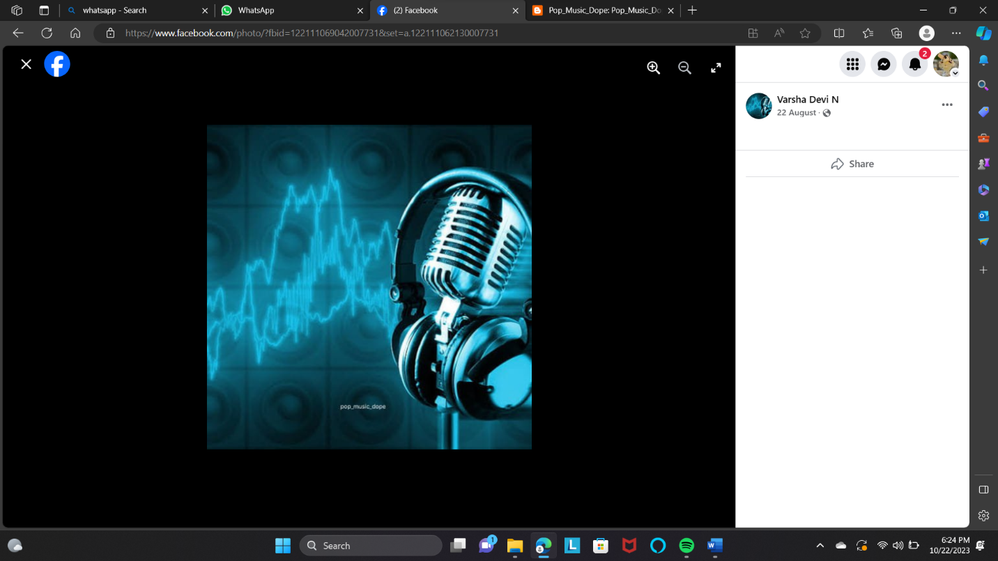

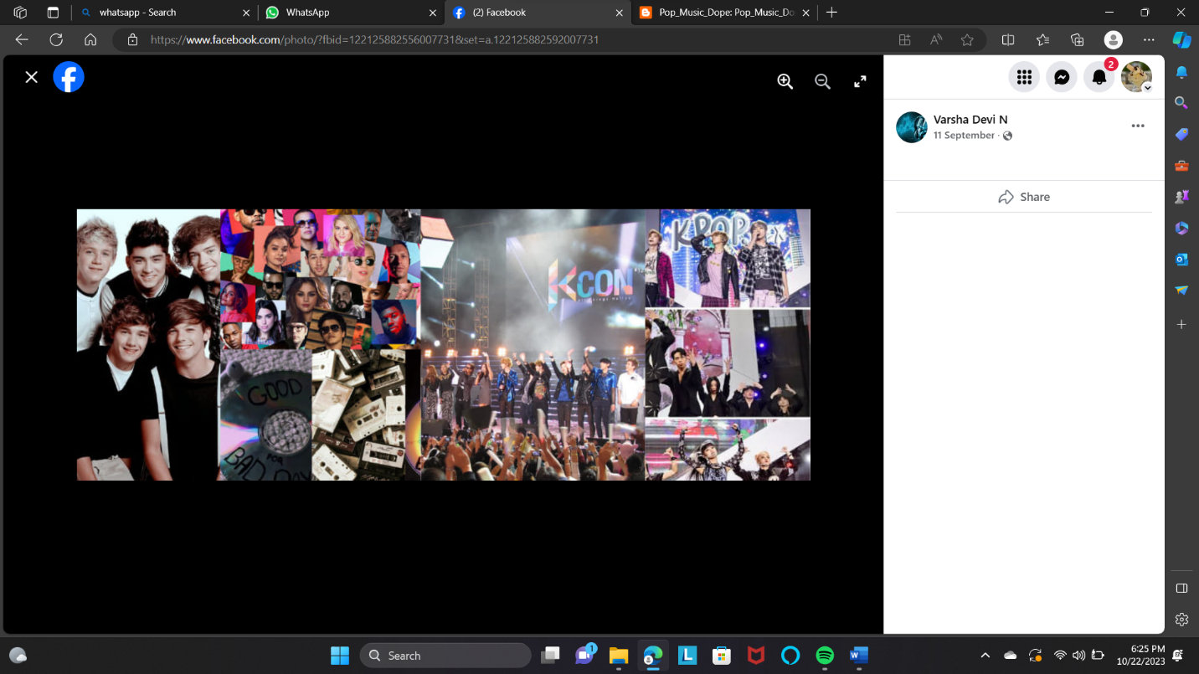

3.Create and design a social media advertisement poster using canva.

Link: Infographics Page Design using Canva

<https://popmusicdope.blogspot.com/2023/09/blog-post_12.html?m=1>

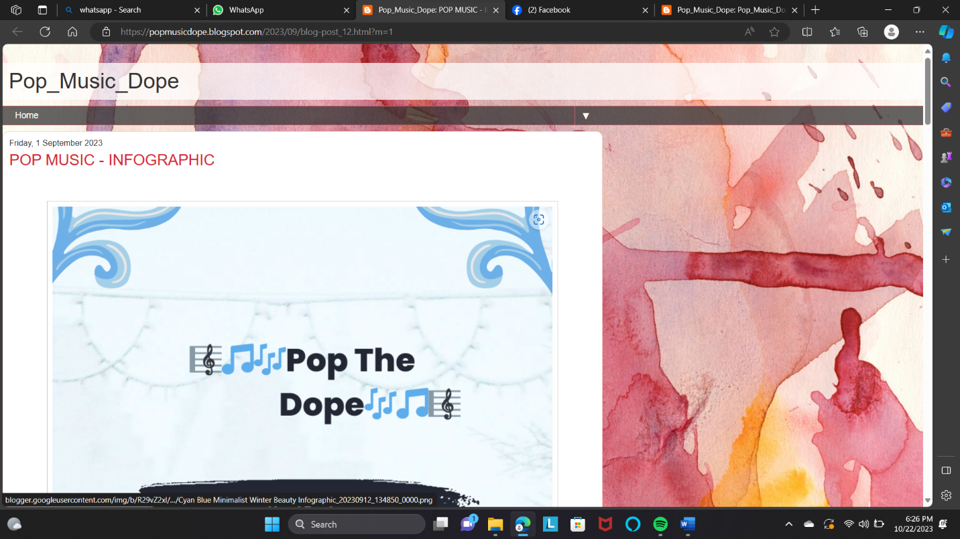

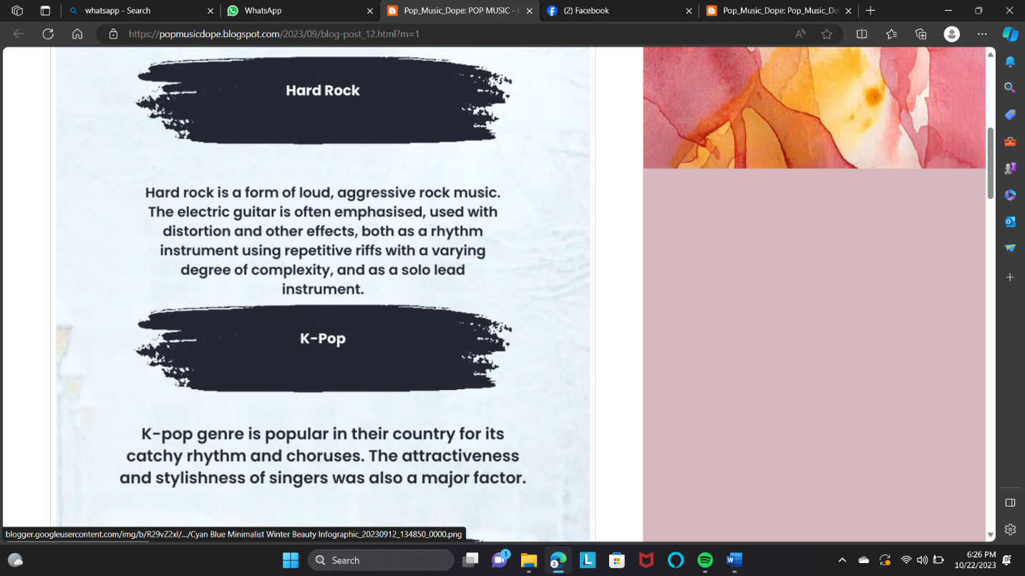

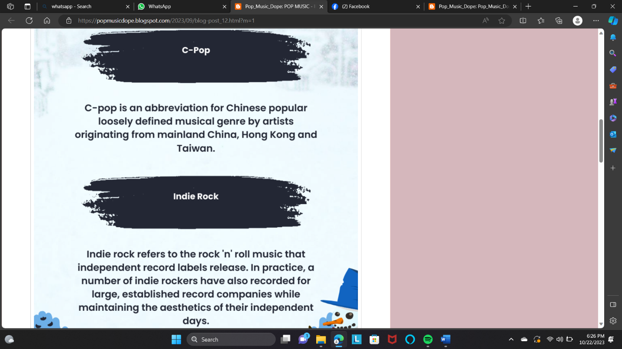

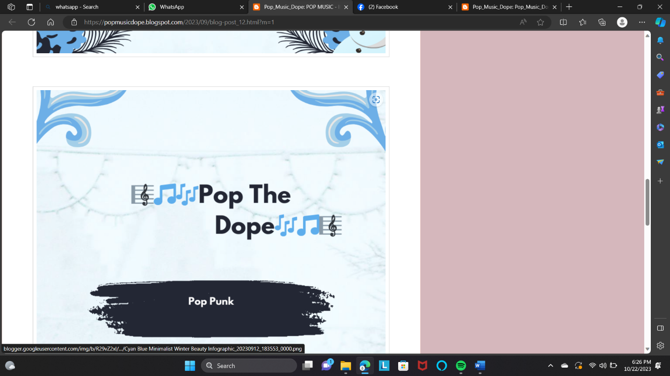

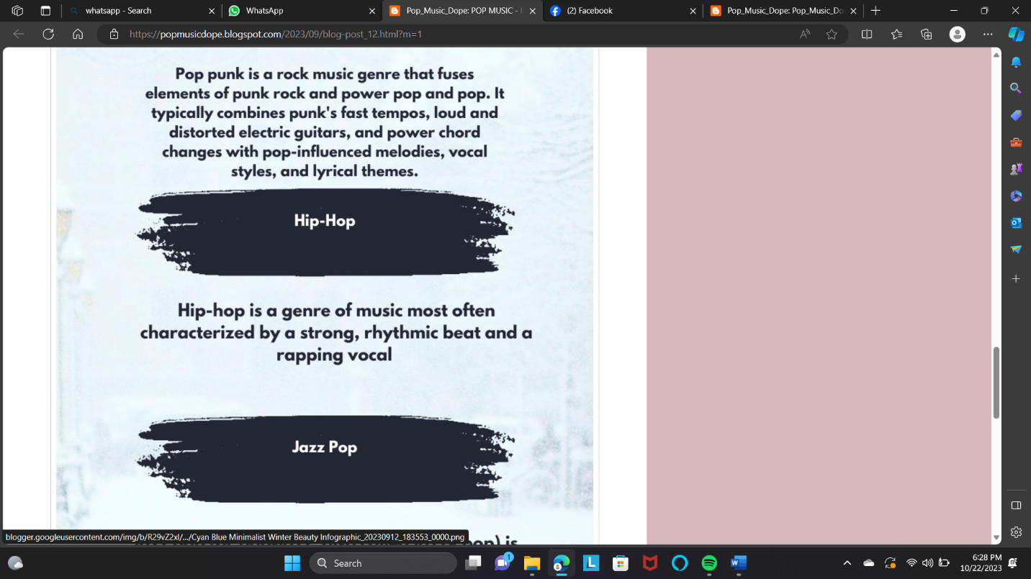

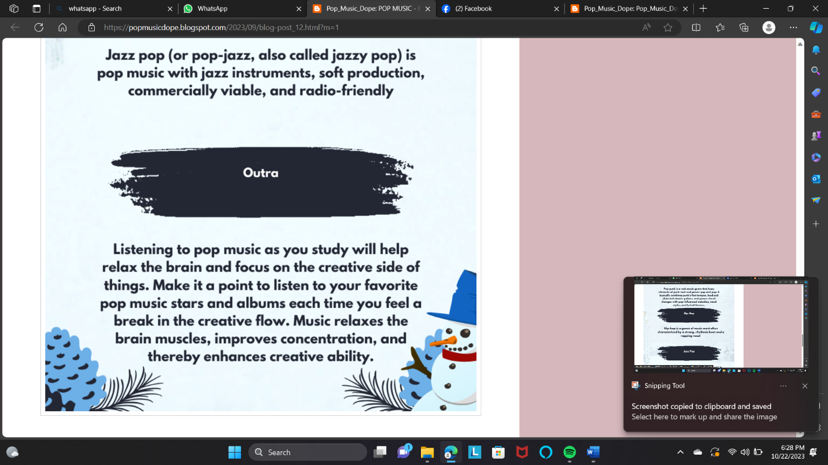

4.Create email newsletter design using MailChimp or canva tool.

Link: Email newsletter design using canva

<https://popmusicdope.blogspot.com/2023/09/blog-post.html?m=1>

screen shot:

